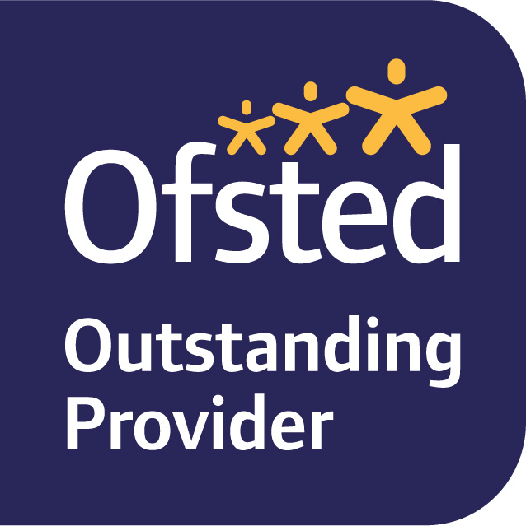  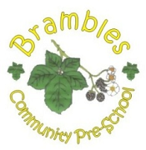  Brambles Community  Pre-school  30 hours childcare  We are pleased to be able to offer up to 30 hours of early years funding  to eligible children. | You, and any partner, must each expect to earn (on average) at least £120 a week (equal to 16 hours at the National Minimum or Living Wage). If you, or your partner, are on maternity, paternity or adoption leave, or you're unable to work because you are disabled or have caring responsibilities, you could still be eligible. Go to:  www.childcarechoices.gov.uk  Here you will find several available funding options  - If you click on “30 Hours childcare” it will take you to the page on which you can apply online, along with links to information on Childcare costs  - You will need a Government Gateway account, this is easy to set up if you do not already have one, and you will be prompted to do this as you go through the website.  - Follow the instructions on applying.  - You will be given a reference number at the end of this if you are eligible, please bring this number into the pre-school so that we can complete the check.  If your child is entitled to 30 hours funding you do not have to take it all, 30 hours is the maximum.

