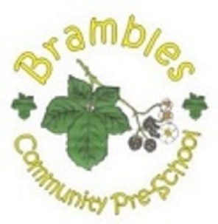
Brambles Healthy Early Years Award (HEYA)

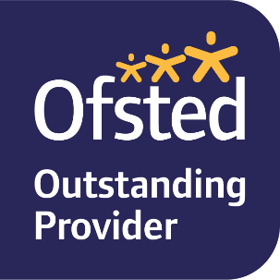
HEYA is run by Southampton City Council. Our setting has achieved the HEYA Bronze award for healthy eating. HEYA is a quality assured programme which helps to improve the health and wellbeing of under 5’s. Helping families to make healthier choices by addressing obesity through healthier nutrition and physical activity choices in addition to improving oral health is a priority for the city.
https://www.facebook.com/southamptonHEYA/

